**Homework #10**

GK Mar 2023

**Instructions:**

Your answers should be *direct and explained*. Show your calculations, formulas, logic you follow etc. Explanations do not have to be verbose; they should be just enough for the instructor and/or TA to understand what you are doing. 80% of the grade goes to the explanations and logic you follow and 20% goes to the result. *Correct result with no explanations gets zero points*.

Please respond with your own words and own understanding. Copying the answers without understanding them, defeats the purpose of this homework -- it violates the code of ethics and the integrity of the course.

* *If you are* ***suspected*** *of copying any part of your answers either from a classmate or a web site (without a reference link), you get a zero to the entire homework.*
* *If it is* ***proven*** *that you have copied or plagiarized, you will be reported to your advisor, your sponsor, and the School; serious consequences to your academic record and/or your student status should follow.*
* *This is applicable to both the giving student and the recipient student*.

For the problems/exercises, it is expected to use a spreadsheet (Excel) and/or your own drawing tool (PowerPoint, Visio, Drawsoft, etc) or make a neat drawing by hand. ***You must embed*** these assets into your WORD file with no external references, specifically for Excel. Unless the TA or I click-and-open the object to see your calculations, you will be missing points. *If you do not know how to do so, ask your colleagues, post the question to the Discussion Homework Area, ask our TA and/or ask me.*

Please use font Arial or Calibri of 9pts or 10pts.

DO NOT REMOVE THIS PAGE FROM YOUR SUBMISSION. Also, answer the questions below:

*How long did it take you to complete this homework? _______4_______ hours*

*How many hours did you work on your project this week? ______2_____ hours*

Table of Contents

1. SLOPE, 20pt 2

2. CCPM, 17pts 4

3. RSCLD, 25pts 5

4. BUFF, 8pts 7

5. RSCLV, 25pts 8

6. RASGN, 5pts 11

## SLOPE, 20pt

Consider the project network below.

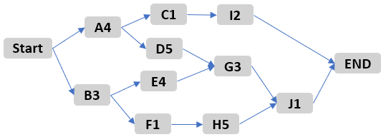

* Suppose the duration of both activities A and D can be reduced by 1 day, at a cost of $15 per day of reduction.
* Also, activities E, G, and H can be reduced in duration by 1 day at a cost of $25 per day of reduction.

1. (2pt) Identify the critical path (CP). How many days? Show such path to the diagram.
2. (1pt) What is the least-cost approach to crash the project by 1-day? How much?
3. (4pt) What is the least-cost approach to crash the project by 1-day more day? How much? Show the new diagram with the new durations and CP(s)
4. (4pt) What is the least-cost approach to crash the project by 1-day more day? How much? Show the new diagram with the new durations.
5. (1pt) What are the new CP(s)
6. (4pt) Based on the above, draw the increment of cost versus the total duration of the project. You must create this in Excel and attach here the graph.
7. (4pt) What is the slope after 2-day reductions of duration?

*Any question you do not answer as asked (i.e. diagrams, explanations) gets zero credit*

**Answer:**

a) Shown below with red arrows; 13 days

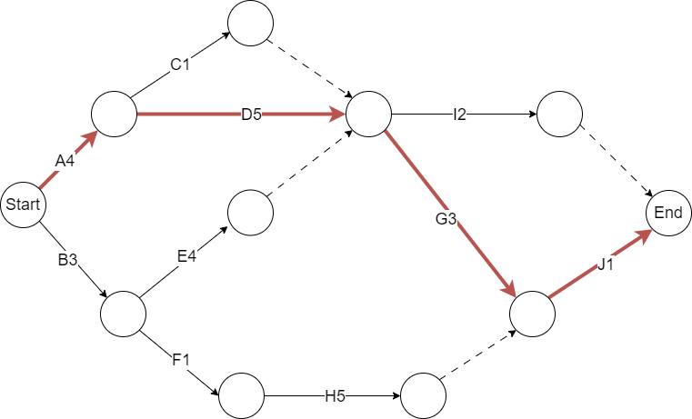

b) Consider nodes on critical path, reducing A or D with cost $15 will be the least-cost approach.

c) Due to the ambiguity of the question, I presume that it requires to crash by 2 days in total.

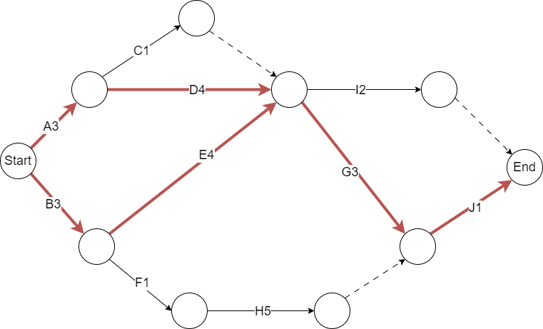

Reduce both A and D by 1 day, which costs $30

d)

Reduce both A, D and G by 1 day, which costs $55

e) Shown above (in d) with red arrows.

f)



g)

## CCPM, 17pts

You have a choice to run your project using CPM or CCPM. You estimated that the total work effort is about 40 person-weeks.

Your CPM plan is shown below.

After you considered the critical people, removed context switching (same person doing two tasks at the same time), etc, you created a Critical Chain plan consisting of CCPM-1, -2, -3 paths with the most critical CCPM-2. Paths -1 and -3 will do “whatever is necessary not to delay path-2”.

Assume also that your finance department “charges the project” based on the number of people and time you use them. (This is equivalent to be paying by person-weeks.)

a. (3 pts) Confirm that the cost of the CPM and CCPM plans is the same.

b. (5 pts) Create the loading chart for CPM, i.e. number of resources per week.

c. (4 pts) Do the same for CCPM and compare (b) and (c ).

d. (5 pts) If the cost is the same, under what conditions/constraints your will use the CPM method, and under what conditions you will follow the CCPM method?

**Answer:**

a)

b)

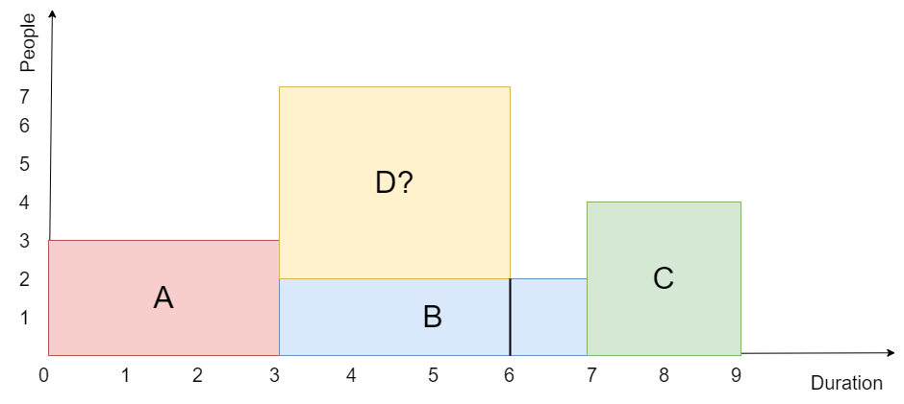

c)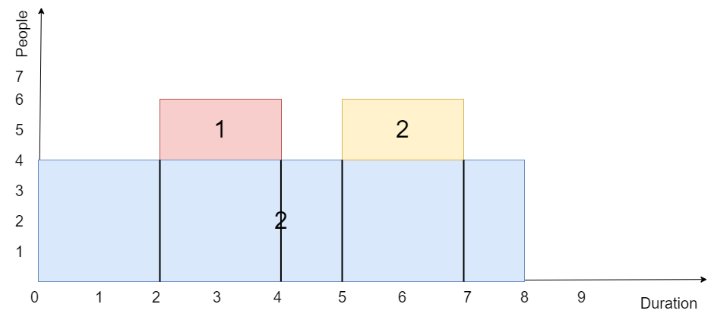

Duration of c is shorter and variations in resource usage is minimized.

d) CPM: resources are not conflict; CCPM: elsewise

## RSCLD, 25pts

You are given the following WBS which includes tasks A…F and resources John, Mary, and Peter.

|  |  |  |  |
| --- | --- | --- | --- |
| TASK | Predecessor | Duration (days) | Resources (people) |
| A |  | 2 | John, Mary |
| B | A | 2 | John |
| C | A | 3 | John |
| D | B, C | 4 | John, Mary |
| E | D | 3 | Peter, John |
| F | D | 1 | Peter, John, Mary |
| G | E, F | 2 | John, Mary |
| end |  |  |  |

1. (10pts) Draw a Gantt Chart using the GanttProject.
   * Use Project|Properties|Calendar to start the project April 3rd, 2023.
   * Set “no tasks can run on weekends”
   * Add the respective resources to each task
   * Right click on the task list to “Manage Columns” and display “Duration” and “Resources”
   * Right click on a graphical task and modify the “Task details” to show “Above” the “Assigned resources” and nothing else
   * Cut and paste (*do not attach!*) your Gantt Chart here. It should look like:

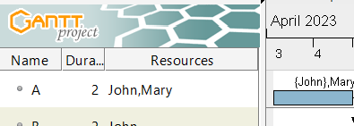

*You will lose 2pts for each of the above steps that us missing* *or done incorrectly*

1. (5pts) View the Resources Chart.
   * Expand all resources to show the tasks associated to each person.
   * Observe in this chart the overloaded resources.
   * Cut and paste (*do not attach!*) your Resource Chart here
2. (10pts) Adjust the tasks so no-one is overloaded.
   * Display the new Gantt Chart – cut and paste it here
   * Display the Resource Chart – cut and paste it here

Assume that each person is assigned to the respective task at 100% level. Assume also that people are not interchangeable, i.e. one cannot take the role of another one.

**Answer:**

a)

b)

c)

应用程序

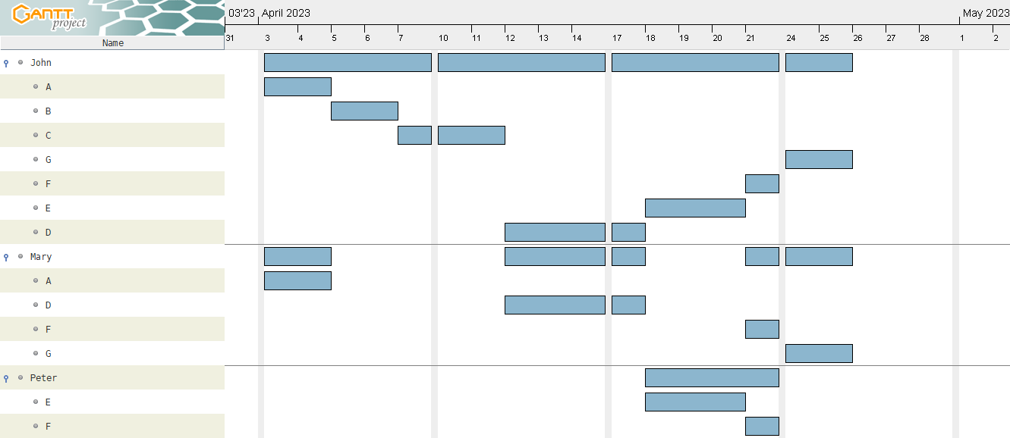

## BUFF, 8pts

Assume that a project consists of three sequential tasks Ta, Tb, Tc and the Critical Path is identical to the Critical Chain of three of them in sequence.

You are also given the “aggressive durations”, “typical durations” and “safe & conservative durations” of the tasks below:

|  |  |  |  |
| --- | --- | --- | --- |
| **Task** | **aggressive** | **typical** | **safe & conservative** |
| Ta | 18 | 20 | 27 |
| Tb | 12 | 15 | 17 |
| Tc | 6 | 7 | 10 |

Your boss wants “high probability” to complete the project, say 95%

1. (2pts) Assume that ***each task*** is planned to be completed with 95% probability. Find when the project will be completed, TE1
2. (2pts) Assume that ***all the tasks*** need to be completed with 95% probability. Find when the project will be completed, TE2
3. (2pts) You apply the CCPM. What could be the ***internal target completion*** TEcc (i.e. before you include any buffers)
4. (2pts) For the CCPM, apply a Project Buffer equal to 6*stddev of the original path. What would be the CCPM duration TE3?

*You must show your calculations either with the formulas you used or by embedding a spreadsheet. No point if not shown.*

**Answer:**



## RSCLV, 25pts

You are given the following AOA which shows tasks a…i and respective durations in days.

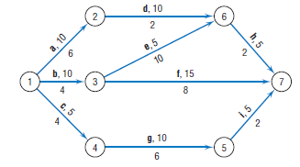

In addition, the AoA shows the number of people per day used for the respective task. For example, “a,10/6” means that task “a” has a duration of 10 days and requires 6-people per day.

1. (5pts) Draw a Gantt Chart using the GanttProject.
   * Use Project|Properties|Calendar to start the project April 1st, 2023.
   * Set “all tasks run as on other days”
   * Right click on the task list to “Manage Columns” and display “Duration” and “Cost”
   * For each task, use the “Resources” tab to add the **people per week** in the “Task cost” area, as “Set explicitly”
   * Cut and paste (*do not attach!*) your Gantt Chart here. Your left panel should look like this, where “Cost” actually means “**number of people per week**”

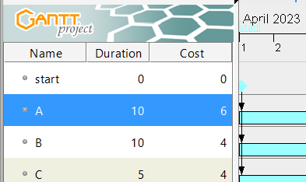

*You will lose 2pts for each of the above steps that us missing* *or done incorrectly*

1. (4pts) Create a spreadsheet with the number of people per week, per task
   * Your spreadsheet should
     1. Have each task in a separate row
     2. Each column to represent a day
     3. The cell value to be the cost of the task for that day.
   * Compute to the bottom row the total cost of the project
   * An example of the first two columns are shown below

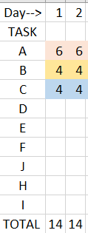

* Cut an paste (do not attach!) this section of the spreadsheet here.

1. (6pts) Create the Loading Chart using Excel. It should look like the one shown in the book (Figure 9.7 and 9.8) and discussed in Class. Cut and paste the Loading chart here.
2. (5pts) Perform Resource Leveling on the Gantt Chart. You may shift resources and possibly extend the duration of the project. ***You may not change the duration of tasks or their dependencies***.
   * Cut and paste the new Gantt Chart here.
3. (5pts) Update your spreadsheet with the new set of tasks. Create a 2nd Loading Chart based on that. Cut and paste here (do not attach!) both the spreadsheet and the chart.

*Please read each question carefully and answer directly what it is asked. When you cut-and-paste pictures, make sure that margins are correct and all text is readable.*

**Answer:**

a)

图形用户界面

b)

c)

d)

图形用户界面

e)

## RASGN, 5pts

Assume that a resource used by activities e, f, g, and h in the ﬁgure below is scarce. To which activity

would you assign the resource, based on the following rules?

1. Minimum slack first
2. Most critical followers
3. Shortest task ﬁrst
4. As late as possible.

**Answer:**

g, of which the slack is minimum (rule a) and the duration is shortest (rule c);

As to rule b, d, they are all equivalent.